


525 McClurg Road
Youngstown, OH 44512
Phone: (330) 427-3000
Email: info@transformercomponents.com
Website: www.transformercomponents.com

TRANSFORMER RADIATOR VALVE
RFQ FORM

CUSTOMER INFO:
NAME: __________________ COMPANY NAME: ________________________
PHONE NO.: ______________ EMAIL: ________________________________

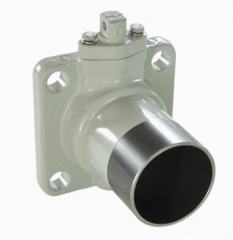
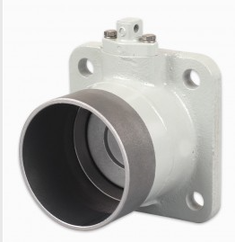
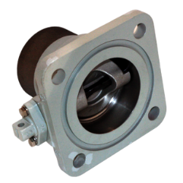
Radiator Weld - on

Valve Type: Weld-on QTY _____ When Needed: _________
- Valve size (Disc Size): 3” ____ 4” ____
- Header Pipe Diameter: 3” ___ 4” ____ 5” (only for SS 4” valves) _____
- Header Pipe Length: (4” to 15”) ________
- Valve Material: Carbon Steel ___, 316 Stainless___,
- Disc & shaft Seal: H-NBR (-50 to +120 ºC) _____ VITON (-40 to +130º C) ______
- O-ring (Flange Seal): H-NBR- MS (-50 to +120 ºC) _____ VITON (-40 to +130º C) ______
Fluor-silicone (-60 to +200º C) _____
- Valve: Assembled ___ Disassembled ____
*(Bolt Circle Pattern = for 3” Valve Φ = 160 mm for 4” Valve Φ = 192 mm)
*(Bolt Holes size Φ 22mm (7/8”))

Radiator Rectangular Wafer.
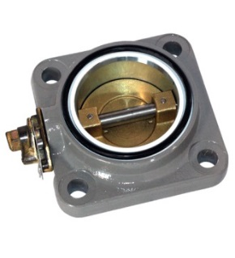
Valve Type: Rectangular Wafer QTY _____ When Needed: __________
- Valve size (Disc Size): 3” ____ 4” ____
- Bolt holes size: Φ 19mm(7/8”) ___, Φ 22mm (7/8”) ____,
- Valve Material: Carbon Steel ___, 316 Stainless___,
- Disc & shaft Seal: H-NBR (-50 to +120 ºC) _____ VITON (-40 to +130º C) ______
- O-ring (Flange Seal): H-NBR- MS (-50 to +120 ºC) _____
VITON (-40 to +130º C) ______ Fluor-silicone (-60 to +200º C) _____
- Valve: Assembled ___ Disassembled ____
*(Bolt Circle Pattern = for 3” Valve Φ = 160 mm for 4” Valve Φ = 192 mm)

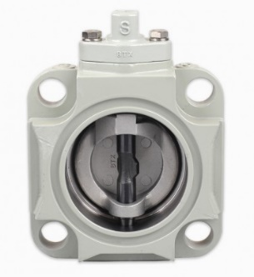

Radiator Round Wafer
Valve Type: Round Wafer QTY _____ When Needed: __________
- Valve size (Disc Size): 3” ___/ 4” ___/ 6" _____/ 8"______/ 10"_______/ 12"_______
- Bolt Circle Pattern Φ = 150mm/ 200mm/ 250mm/ 300mm
- No of holes: 6 holes/ 8 holes/ 8 holes/ 8 holes/ 8 holes.
- Stud-bolt size: 8 holes/ 8 holes/ 8 holes/ 8 holes.
- Bolt holes size: various sizes
- Valve Material: Cast Iron Body ___,
- Disc & shaft Seal: H-NBR (-50 to +120 ºC) _____ VITON (-40 to +130º C) ______
- O-ring (Flange Seal): H-NBR- MS (-50 to +120 ºC) _____ VITON (-40 to +130º C) ______
*(Dimensions changeable as requirements dictate)
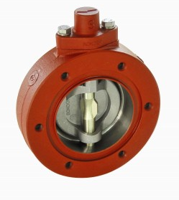

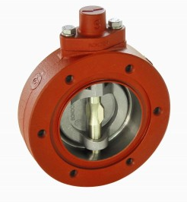

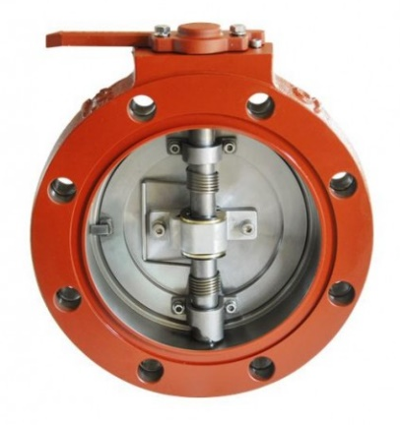

Double Flange Radiator Valve
Valve Type: Double flange Radiator QTY _____ When Needed: __________

- Application: Power Transformer Replacement valve for Beck Power transformer .
- Valve size (Disc Size): 4” ___/ 6" _____/ 8"_____.
- Valve Material: - Cast Iron Body ___,
- Bolt Circle Pattern ANSI bolt circle Φ = 150mm/ 200mm/ 250mm/ 300mm
- No of holes/holes size: : 6 holes/ 8 holes/ 8 holes/ 8 holes/ 8 holes. Size 22mm
- Disc & shaft Seal: NBR (-50 to +120 ºC) _____
- Paint: - ANSI 70 Gray Painted

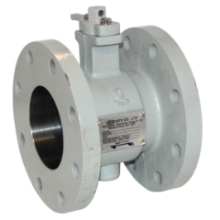
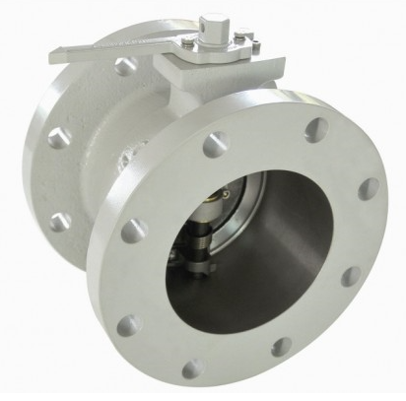
For further information on this product and others from Specialty Transformer Components please visit our website at www.transformercomponents.com.

